Access For All: Integrated Educational and Employment System for Lupaoeños

Justine Joy S. Alo   
*Department of Information Technology*  
*Central Luzon State University*Science City of Muñoz, Philippines   
alo.justine@clsu2.edu.ph

Cenon Conrado C. Divina  
 *Vision and Image Processing Laboratory*  
*Department of Information Technology*  
*Central Luzon State University*Science City of Muñoz, Philippines   
cenonconrado.divina@clsu2.edu.phMary Graciel P. Lictawa  
*Department of Information Technology*  
*Central Luzon State University*Science City of Muñoz, Philippines   
lictawa.mary@clsu2.edu.ph

Ivan Christian L. Salinas  
Vision and Image Processing Laboratory  
*Department of Information Technology*  
*Central Luzon State University*Science City of Muñoz, Philippines   
ivanchristian.salinas@clsu2.edu.phEdwin B. Tejada  
*Department of Information Technology*  
*Central Luzon State University*Science City of Muñoz, Philippines   
tejada.edwin@clsu2.edu.ph

Angelika S. Balagot  
*Mobile and Cloud Computing Laboratory*  
*Department of Information Technology*  
*Central Luzon State University*Science City of Muñoz, Philippines   
balagot.angelikas@clsu2.edu.ph

*Abstract*—The “Access for All: Integrated Educational and Employment System for Lupaoeños” addresses inefficiencies in manual processes for scholarship and job applications. This web-based platform simplifies application procedures, expands opportunities, and fosters community development. Employing PHP, HTML, and CSS, the system enhances accessibility to scholarships and job opportunities, enabling applicants to connect seamlessly with educational and employment avenues. Real-time updates and analytics offer transparent and inclusive solutions for individual and communal growth.

***Keywords—scholarship, employment, web application, PHP, education***

# Introduction

A scholarship is a valuable form of financial assistance that helps students cover their education costs, such as textbooks and other related expenses. These scholarships support students in pursuing their educational ambitions and achieving their objectives. Typically, scholarships are awarded based on academic merit and financial need, ensuring students have access to the necessary resources to succeed.

Employment opportunities offer individuals diverse choices to secure jobs and work across various industries, including the public sector, government, and self-employment. These jobs provide viable career paths and opportunities for personal and professional growth. They are essential components of economic growth and individual development.

In the Municipality of Lupao, applying for scholarships and job vacancies is conducted through manual, in-person procedures. This method is challenging and time-consuming for residents as it requires physical visits to municipal offices, waiting in queues, and submitting physical documents. Additionally, incomplete and outdated information poses another obstacle, making it difficult for residents to find precise and timely details about scholarships and job opportunities within the local government unit (LGU). Consequently, this deficiency results in missed chances, as people may not know about opportunities aligned with their skills and career goals.

Scholarships and employment opportunities are critical for personal and community development. Scholarships enable financially constrained students in Lupao to pursue higher education, benefiting both individuals and the community. Similarly, work opportunities contribute to workforce readiness, lessen financial constraints on students, promote talent and merit, expand access to higher education through scholarships, and support economic growth and talent retention. These outcomes are transformative for both individuals and the community.

As proposed in "Access for All: Lupaoeños System," an efficient and effective job application procedure is crucial for Lupao residents. Simplifying the application process and making it more accessible allows people to locate appropriate information within the local government.

# literature review

This section provides a comprehensive analysis of relevant studies and alternatives that inform the development of the proposed system. The literature is divided into two parts: an overview of previous studies and findings, and existing alternatives. These reviews establish the theoretical framework and identify knowledge gaps, contributing to the research design and innovative solutions.

## Previous Studies and Findings

• **Smart Scholarship System** — The current method for applying for scholarships requires physical presence, which is time-consuming and inefficient. A proposed system for Abu Dhabi University integrates scholarship facilitation and job creation, enabling students to apply for scholarships, check application statuses, and support office operations. This approach empowers residents by providing educational opportunities and fostering access to employment through apprenticeship programs [3].

• **Scholarship Management for International Students in China** — Li and Yang highlighted the importance of aligning scholarship systems with education strategies, focusing on fairness and transparency in allocation. The proposed system for Lupao mirrors this approach, addressing inequitable distribution and creating a nurturing environment for students [4].

• **Online Tertiary-Level Scholarship Applications** —  
Blancaflor et al. developed a web-based scholarship management system (APPly), emphasizing usability and efficiency. Enhancements include SMS notifications and centralized file management. The proposed system incorporates these features, improving access to job opportunities alongside scholarships [5].

• **Inclusion of Job Applications in E-Government Systems** — Estoquia et al. proposed a system offering analytics dashboards and real-time communication for job applicants and employers. The proposed Lupao system adopts similar features, ensuring seamless interaction and status updates [4].

•**Job Standard Parameters from Online Vacancies** — Putro and Rakhmawati demonstrated the efficiency of online job vacancy systems. The proposed system builds on this by providing detailed job listings and direct communication channels for applicants and employers [8].

## Existing Alternatives

•**SMS Notification for Scholarship Management** — This system uses SMS to manage applications but lacks comprehensive scholarship listings. The proposed system enhances this with data dashboards and messaging features for better usability [9].

•**Job Matcher with Collaborative Filtering** — Mendez and Bulanadi introduced a system for matching graduates’ skills with job vacancies. The proposed system extends this functionality by integrating job postings for private sectors and enabling real-time employer-applicant interactions [6].

•**Civil Service Commission (CSC) Job Portal** — The CSC portal lists government vacancies but faces security concerns. The proposed system incorporates ID-based authentication to prevent fraud and ensure data integrity [1].

•**E-Scholarship Application System** — Pascual’s E-Scholarship system simplifies scholarship applications but is limited to specific qualifications and fields. The proposed system offers equal access to all residents, without restrictions on courses or entrance exams [7].

•**Web-Based Information Systems for Scholarships** — Existing systems improve accessibility but lack data analysis features. The proposed system unifies scholarships and job opportunities with analytics-driven notifications and messaging capabilities [3].

.

## Gaps in Existing Research

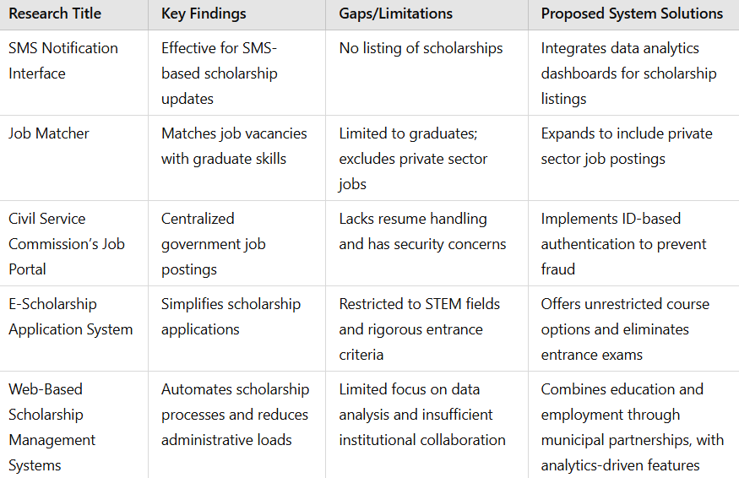

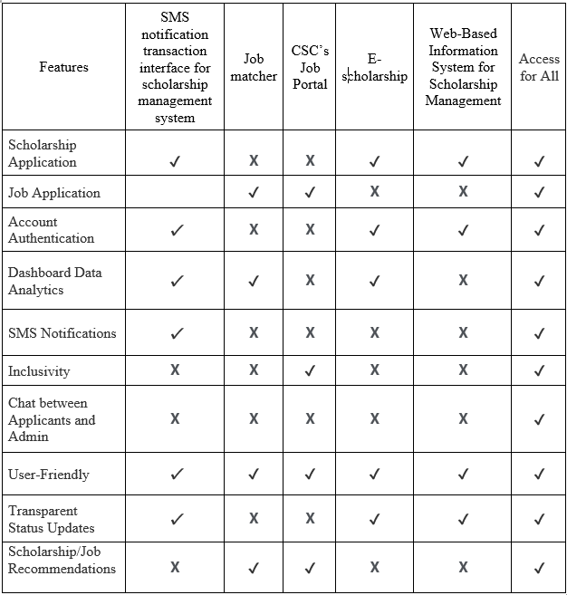

## Synthesis

In the Philippines, managing scholarships and job placement is a complex and demanding task due to the high number of applicants and the limited positions available. To address these challenges, various systems have been developed to simplify the application process, offer useful features, and streamline operations for applicants.

Several alternatives have been implemented to manage scholarships and job opportunities. One approach utilizes QR code tracking and SMS notifications for application management, providing real-time updates to applicants. Another system employs a job matcher web application, leveraging collaborative filtering recommender systems to align applicants’ qualifications with available job opportunities.

The Civil Service Commission (CSC) also offers a job portal that lists government job openings. While the portal provides centralized information, it does not handle the application process directly, leaving agencies responsible for managing applications. Additionally, the E-Scholarship Application System offers a web-based platform for scholarship management, simplifying the application process and improving user accessibility.

Although these systems have their strengths, they also exhibit limitations. The proposed system aims to address these gaps by integrating scholarship and job application processes into a unified platform. This approach is expected to enhance efficiency, accessibility, and transparency, making the application process faster and more user-friendly for residents.

# methodology

# Results and discussion

# Conclusion

Before you begin to format your paper, first write and save the content as a separate text file. Complete all content and organizational editing before formatting. Please note sections A-D below for more information on proofreading, spelling and grammar.

Keep your text and graphic files separate until after the text has been formatted and styled. Do not use hard tabs, and limit use of hard returns to only one return at the end of a paragraph. Do not add any kind of pagination anywhere in the paper. Do not number text heads-the template will do that for you.

## Abbreviations and Acronyms

Define abbreviations and acronyms the first time they are used in the text, even after they have been defined in the abstract. Abbreviations such as IEEE, SI, MKS, CGS, sc, dc, and rms do not have to be defined. Do not use abbreviations in the title or heads unless they are unavoidable.

## Units

* Use either SI (MKS) or CGS as primary units. (SI units are encouraged.) English units may be used as secondary units (in parentheses). An exception would be the use of English units as identifiers in trade, such as “3.5-inch disk drive”.
* Avoid combining SI and CGS units, such as current in amperes and magnetic field in oersteds. This often leads to confusion because equations do not balance dimensionally. If you must use mixed units, clearly state the units for each quantity that you use in an equation.
* Do not mix complete spellings and abbreviations of units: “Wb/m2” or “webers per square meter”, not “webers/m2”. Spell out units when they appear in text: “. . . a few henries”, not “. . . a few H”.
* Use a zero before decimal points: “0.25”, not “.25”. Use “cm3”, not “cc”. (*bullet list*)

## Equations

The equations are an exception to the prescribed specifications of this template. You will need to determine whether or not your equation should be typed using either the Times New Roman or the Symbol font (please no other font). To create multileveled equations, it may be necessary to treat the equation as a graphic and insert it into the text after your paper is styled.

Number equations consecutively. Equation numbers, within parentheses, are to position flush right, as in (1), using a right tab stop. To make your equations more compact, you may use the solidus ( / ), the exp function, or appropriate exponents. Italicize Roman symbols for quantities and variables, but not Greek symbols. Use a long dash rather than a hyphen for a minus sign. Punctuate equations with commas or periods when they are part of a sentence, as in:

*a + b = τ* (1)

Note that the equation is centered using a center tab stop. Be sure that the symbols in your equation have been defined before or immediately following the equation. Use “(1)”, not “Eq. (1)” or “equation (1)”, except at the beginning of a sentence: “Equation (1) is . . .”

## Some Common Mistakes

* The word “data” is plural, not singular.
* The subscript for the permeability of vacuum **0, and other common scientific constants, is zero with subscript formatting, not a lowercase letter “o”.
* In American English, commas, semicolons, periods, question and exclamation marks are located within quotation marks only when a complete thought or name is cited, such as a title or full quotation. When quotation marks are used, instead of a bold or italic typeface, to highlight a word or phrase, punctuation should appear outside of the quotation marks. A parenthetical phrase or statement at the end of a sentence is punctuated outside of the closing parenthesis (like this). (A parenthetical sentence is punctuated within the parentheses.)
* A graph within a graph is an “inset”, not an “insert”. The word alternatively is preferred to the word “alternately” (unless you really mean something that alternates).
* Do not use the word “essentially” to mean “approximately” or “effectively”.
* In your paper title, if the words “that uses” can accurately replace the word “using”, capitalize the “u”; if not, keep using lower-cased.
* Be aware of the different meanings of the homophones “affect” and “effect”, “complement” and “compliment”, “discreet” and “discrete”, “principal” and “principle”.
* Do not confuse “imply” and “infer”.
* The prefix “non” is not a word; it should be joined to the word it modifies, usually without a hyphen.
* There is no period after the “et” in the Latin abbreviation “et al.”.
* The abbreviation “i.e.” means “that is”, and the abbreviation “e.g.” means “for example”.

An excellent style manual for science writers is [7].

# Using the Template

After the text edit has been completed, the paper is ready for the template. Duplicate the template file by using the Save As command, and use the naming convention prescribed by your conference for the name of your paper. In this newly created file, highlight all of the contents and import your prepared text file. You are now ready to style your paper; use the scroll down window on the left of the MS Word Formatting toolbar.

## Authors and Affiliations

**The template is designed for, but not limited to, six authors.** A minimum of one author is required for all conference articles. Author names should be listed starting from left to right and then moving down to the next line. This is the author sequence that will be used in future citations and by indexing services. The author sequence's numbering should be removed from the manuscript, such as 1st, 2nd, 3rd, 4th, etc. Names should not be listed in columns nor group by affiliation. Please keep your affiliations as succinct as possible (for example, do not differentiate among departments of the same organization). Use italic typeface for both department’s and organization’s names. Postal code should omit in affiliation.

### For papers with more than six authors: Add author names horizontally, moving to a third row if needed for more than 8 authors.

### For papers with less than six authors: To change the default, adjust the template as follows.

#### Selection: Highlight all author and affiliation lines.

#### Change number of columns: Select the Columns icon from the MS Word Standard toolbar and then select the correct number of columns from the selection palette.

#### Deletion: Delete the author and affiliation lines for the extra authors.

## Identify the Headings

Headings, or heads, are organizational devices that guide the reader through your paper. There are two types: component heads and text heads.

Component heads identify the different components of your paper and are not topically subordinate to each other. Examples include Acknowledgments and References and, for these, the correct style to use is “Heading 5”. Use “figure caption” for your Figure captions, and “table head” for your table title. Run-in heads, such as “Abstract”, will require you to apply a style (in this case, italic) in addition to the style provided by the drop down menu to differentiate the head from the text.

Text heads organize the topics on a relational, hierarchical basis. For example, the paper title is the primary text head because all subsequent material relates and elaborates on this one topic. If there are two or more sub-topics, the next level head (uppercase Roman numerals) should be used and, conversely, if there are not at least two sub-topics, then no subheads should be introduced. Styles named “Heading 1”, “Heading 2”, “Heading 3”, and “Heading 4” are prescribed.

## Figures and Tables

#### Positioning Figures and Tables: Place figures and tables at the top and bottom of columns. Avoid placing them in the middle of columns. Large figures and tables may span across both columns. Most graphics are published at one column width (3.5 inches / 21 picas wide) or two column width (7.16 inches / 43 picas wide). Figure captions should be below the figures; table heads should appear above the tables. Insert figures and tables after they are cited in the text. Use the abbreviation “Fig. 1”, even at the beginning of a sentence.

1. Table Type Styles

| Table Head | Table Column Head | | |
| --- | --- | --- | --- |
| Table column subhead | Subhead | Subhead |
| copy | More table copya |  |  |

1. Sample of a Table footnote. (*Table footnote*)
2. Example of a figure caption. (*figure caption*)

Figure Labels: Use 8 point Times New Roman for Figure labels. Use words rather than symbols or abbreviations when writing Figure axis labels to avoid confusing the reader. As an example, write the quantity “Magnetization”, or “Magnetization, M”, not just “M”. If including units in the label, present them within parentheses. Do not label axes only with units. In the example, write “Magnetization (A/m)” or “Magnetization {A[m(1)]}”, not just “A/m”. Do not label axes with a ratio of quantities and units. For example, write “Temperature (K)”, not “Temperature/K”.

#### Embedding Fonts: Ensure all parts of your graphic can be viewed when opened on another computer. As you prepare your graphics, select fonts from the recommended list: Helvetica, Times New Roman, Arial, Cambria, and Symbol.

If you are supplying EPS, PS, or PDF files: either convert all text to outlines or embed the fonts. Some fonts may be native only to your operating system. If the fonts are not embedded, parts of the graphic may be distorted or missing when opened on another computer.

Typefaces and type sizes should be consistent in all your graphics and tables. Type should appear approximately 9-10 point when viewed at full size.

##### Acknowledgment *(Heading 5)*

The preferred spelling of the word “acknowledgment” in America is without an “e” after the “g”. Avoid the stilted expression “one of us (R. B. G.) thanks ...”. Instead, try “R. B. G. thanks...”. Put sponsor acknowledgments in the unnumbered footnote on the first page.

##### References

1. (n.d.). "Civil Service Commission - The Official Website of the Philippines Civil Service Commission," accessed May 21, 2024. [Online]. Available: <https://csc.gov.ph/>
2. (n.d.). "Civil Service Commission - The Official Website of the Philippines Civil Service Commission," accessed May 21, 2024. [Online]. Available: <https://csc.gov.ph/>
3. M. S. Al-Ayyubi and B. Maulana, "Designing a Web-Based Information System for Scholarship Management: Supporting Access and Rapid Dissemination of Information," *ITEJ*, vol. 8, no. 1, June 28, 2023. [Online]. Available: <https://doi.org/10.24235/itej.v8i1.111>
4. D. F. Berido, S. A. A. Pingol, P. D. Ramil, K. D. Villacaol, C. J. Centeno, and D. S. Abando, "Development of scholarship automation system for student qualification program applied to college universities using regression analysis," *World Journal of Advanced Research and Reviews*, Nov. 30, 2023. [Online]. Available: https://doi.org/10.30574/wjarr.2023.20.3.2421
5. E. Blancaflor, P. A. I. Caseñas, L. J. H. Rocamora, J. I. Y. Rosete, and W. Rey, "APPly: A Design of an Online Tertiary Level Scholarship Application Management System," in *Proc. Int. Commun. Eng. Cloud Comput. Conf. (CECCC)*, Oct. 28-30, 2022, pp. 74-78. [Online]. Available: <https://doi.org/10.1109/CECCC56460.2022.10069218>
6. J. S. Mendez and J. D. Bulanadi, "Job Matcher: A Web Application Job Placement Using Collaborative Filtering Recommender System," *Consortia Academia*, vol. 9, no. 2, pp. 103-120, July 13, 2020. [Online]. Available: <https://doi.org/10.5861/ijrse.2020.5810>
7. M. R. Pascual, "E-Scholarships Application System - Undergraduate," Feb. 25, 2023. [Online]. Available: <https://www.scribd.com/>
8. H. H. Paturo and N. Rakhmawati, "Job Standard Parameters from Online Job Vacancy," *IPTEK Journal of Proceedings Series*, Mar. 9, 2021.
9. K. A. S. Secugal, J. P. Sermeno, and N. E. Mistio, "QR-Code tracking and SMS notification transaction interface for scholarship management system," *Int. J. Appl. Sci. Eng.*, vol. 18, June 21, 2021. [Online]. Available: <https://doi.org/10.6703/IJASE.202106_18(4).004>
10. T. Aytemiz, "How does the SDLC play a role in the success of product development and launch?" *Medium*, Jan. 14, 2023. [Online]. Available: <https://medium.com/agileinsider/how-does-the-sdlc-play-a-role-in-the-success-of-product-development-and-launch-a17baaac1054>